**INTRO TO MONGODB**

1. Create a Database named 'MYWall'
2. Create two collections named 'user and ''post'
3. Insert some post related information like post_id, title, description , posted_by, comments, created_at etc…
4. Comments should be an array of objects which has comment_id, message, timestamp

Solution : Solution to these 4 questions above in screenshots below

1st screenshot has details of user collection

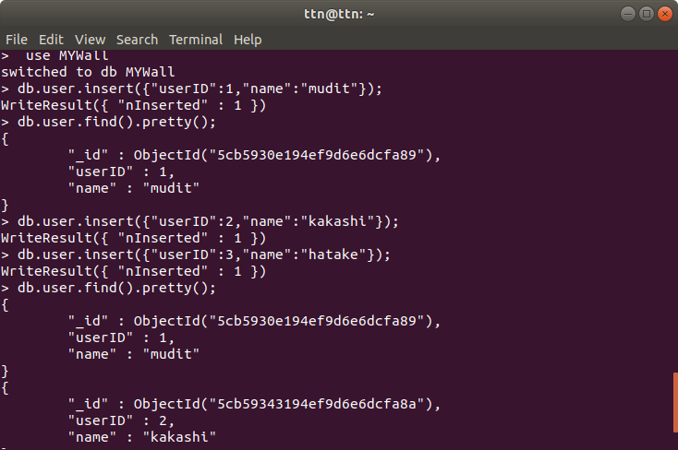

2nd screenshot has details of post collection

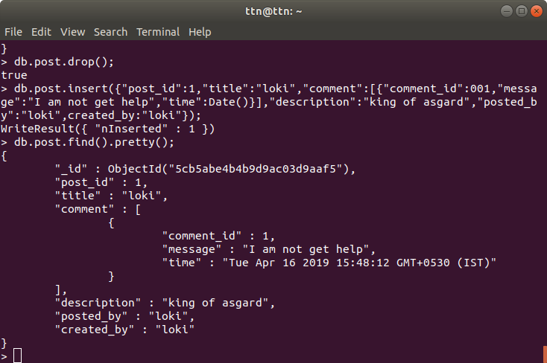

5. Write query to add a new comment for a post

Solution :

Update query takes 3 arguments.   
1st argument takes condition (which query to look for)

2nd argument takes data to update

3rd has options as required.

$push operator has been used to insert new comment in comments array.

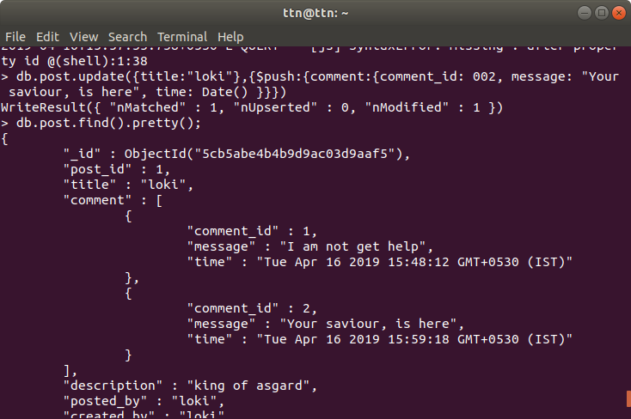

6. Write a query to update comment of a post

Solution :

$set operator has been used so that the update query won’t overwrite existing data.

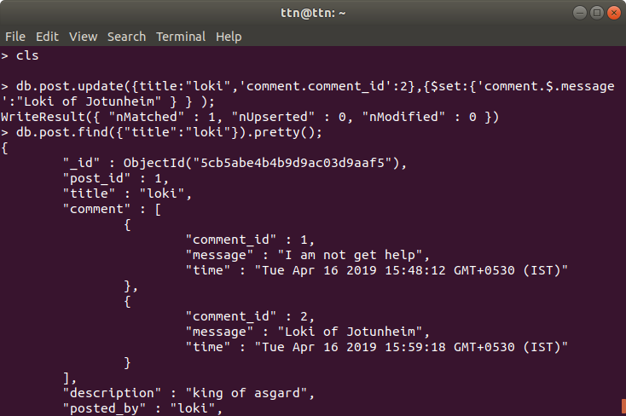

7. Write a query to update description of a post

Solution :

query i wrote : db.post.update({title:”thor”},{description:”Odin’s Second born”});  
db.post.find({title:”Thor”});

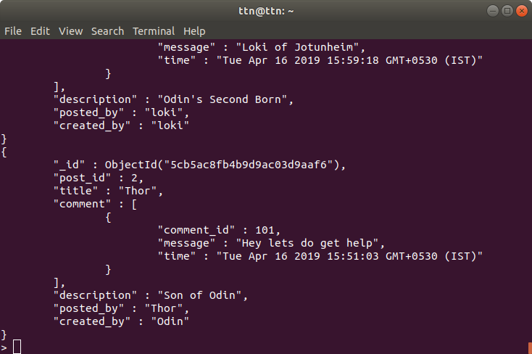

8 . Write query to remove a comment

Solution :

$pull operator has been used to remove a particular item from array.

Could have used $pop too to remove an item from array either for beginning or from end.

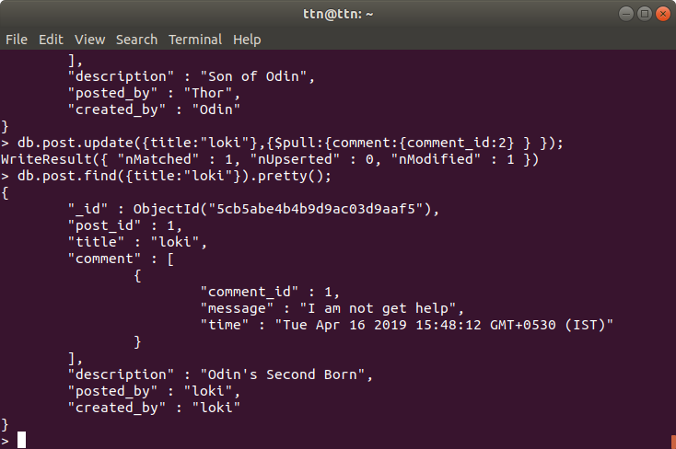

P.S : whole query and output data couldn't be captured in a single screenshot, hence they are a bit messy. I have tried to explain what I did in those questions that did not capture everything, and if they still confuse, i can come and explain them myself.